Business Process: Special Facilities Rule 2

Contact
Business Process Owner | Billing Operations – Billing Solutions
Subject Matter Expert(s) | Amanda De La Cruz, Katherine Martinez, Shannon Whitley
Key Contact | Maya Duarte
Key Role | Customer Services Representative II  Senior Customer Services Representative
Date Created | 5/5/2026

Business Process Overview
Special facilities are nonstandard facilities or value-added services that SMUD installs, owns, maintains, or allocates when a customer requests something beyond standard service, such as redundant service, customer-requested redundancy, vaults, or service upgrades. These facilities are in addition to or in substitution for standard facilities, and the customer is responsible for the additional costs.
The process starts when a customer submits a Design and Construction application. Distribution Planning reviews the request and determines whether it qualifies as a Rule 2 special facilities case. If so, the team identifies the needed work groups and coordinates with them to define the scope and estimate the cost.
Next, SMUD presents the project cost, payment options, and any required advance payment. Legal prepares the agreement template, populates it with known information, and reviews it for updates. A Staffing Summary Sheet (SSS) is created and distributed amongst the appropriate reviewers and approvers. Once the SSS is finalized internally our customer meets with SMUD to review the final agreement. If approvals are complete, our customer signs the agreement and makes the advance payment. Thereafter, SMUD schedules and completes the work.
Afterward, SMUD updates internal systems, stores the contract, and notifies Distribution Planning. Billing is then notified to begin billing, set up Installation Fact Operands, and update the Manual Billing Spreadsheet. The Strategic Account Advisor (SAA) monitors progress, and Accounting is informed when the work is complete and when the bill has been updated correctly.

Business Process Assumptions, Prerequisites, Dependencies
(Assumptions pertaining to the business process)
People | - Assumptions:  - Distribution Planning, Legal, Billing, the Strategic Account Advisor (SAA), and Accounting are available and understand their roles in the Special Facilities process.  - Prerequisites:  - A customer submitted a Design and Construction application, and the reviewers and approvals needed have been identified.  - Dependencies:  - The process depends on coordination across Distribution Planning, Legal, Billing, SAA, and Accounting, as well as customer participation to review, sign, and pay the agreement.
Process | - Assumptions:  - The request qualifies as a case of Rule 2 Special Facilities, and SMUD agrees to provide the special facilities under contract.  - Prerequisites:  - The request has been received, the scope and cost have been determined, the agreement template has been prepared, and the Staffing Summary Sheet has been circulated for review.  - Dependencies:  - Distribution Planning defines scope and cost  - Legal prepare contractual agreement  - Customer sign and make any required advance payments  - Billing process billing setup after notification  - SAA monitor progress and informs Accounting at completion.
Technology | - Assumptions:  - The systems used to store agreements, track billing, and maintain the Manual Billing Spreadsheet are available and contain accurate data.  - Prerequisites:  - The contract repository, billing tracking tools, and supporting spreadsheets or validation tables must be available before execution begins.  - Dependencies:  - The process depends on internal systems for agreement storage and billing setup, manual billing tracking tools, and the systems used by the SAA and Accounting to confirm updates and completion.

Process Flowchart
Special Facilities Rule 2 Process Mapping As Is.vsdx

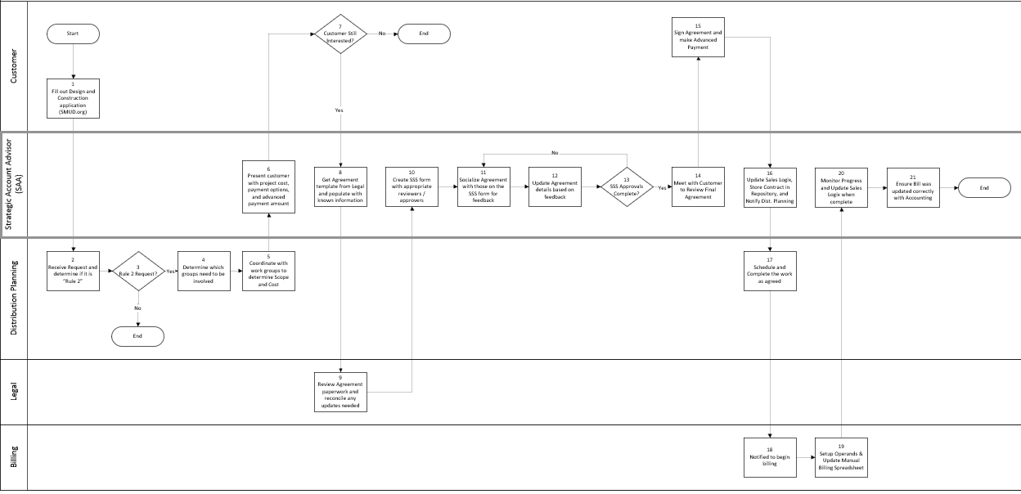

Task Description
Id | Task Description | Procedure
1 | Fill out Design and Construction application (SMUD.org) | The customer initiates the Special Facilities request by completing the Design and Construction application through SMUD.org.
2 | Receive request and determine if it is “Rule 2” | Distribution Planning receives the request and evaluates whether the request qualifies as a Rule 2 Special Facilities case.
3 | Rule 2 Request? | Distribution Planning makes the decision on whether the request proceeds under the Rule 2 process.
4 | Determine which groups need to be involved | Distribution Planning identifies the internal groups needed to support the request review and fulfillment.
5 | Coordinate with work groups to determine scope and cost | Distribution Planning coordinates with the required work groups to define the project scope and estimate the associated cost.
6 | Present customer with project cost, payment options, and advanced payment amount | SAA presents the customer with the project cost, available payment options, and required advance payment amount.
7 | Customer Still Interested? | SAA checks whether the customer wants to continue after scope and cost are identified.
8 | Get Agreement template from Legal and populate with known information | SAA obtains the agreement template from Legal and completes it with the project information already known.
9 | Review Agreement paperwork and reconcile any updates needed | Legal reviews the agreement paperwork and reconciles any needed changes or updates.
10 | Create SSS form with appropriate reviewers / approvers | SAA prepares the Staffing Summary Sheet(SSS) and adds the appropriate reviewers and approvers.
11 | Socialize Agreement with those on the SSS form for feedback | SAA circulates the agreement to the reviewers and approvers listed on the SSS form for feedback.
12 | Update Agreement details based on feedback | SAA updates the agreement based on comments and feedback received from reviewers.
13 | SSS Approvals Complete? | SAA verifies whether all required SSS approvals have been completed.
14 | Meet with Customer to Review Final Agreement | SAA meets with the customer to review the final agreement before execution.
15 | Sign Agreement and make Advanced Payment | The customer signs the agreement and makes the required advance payment.
16 | Update Sales Logix, Store Contract in Repository, and Notify Dist. Planning | SAA updates Sales Logix, stores the contract in the repository, and notifies Distribution Planning.
17 | Schedule and Complete the work as agreed | Distribution Planning schedules and completes the work according to the agreement.
18 | Notified to begin billing | Billing is notified that billing can begin for the project.
19 | Setup Operands & Update Manual Billing Spreadsheet | Billing sets up the operands and updates the Manual Billing Spreadsheet and notify the SAA.
20 | Monitor Progress and Update Sales Logix when complete | SAA monitors progress and updates Sales Logix when the work is complete.
21 | Ensure Bill was updated correctly with Accounting | SAA confirms with Accounting that the bill was updated correctly.

Business Rules
Id | Event Name | Business Rules
3 | Rule 2 Request | Special Facilities assessments are required when customer-requested facilities are in excess of standard facilities or are in substitution for standard facilities, and when the installation is not expected to recover SMUD’s ongoing cost of ownership through normal rates.
3 | Exceptions to Rule 2 | A Special Facility assessment is not necessary when the cost of ownership remains neutral, when SMUD is the sole customer or purchaser, or when another billing mechanism exists to recover the costs. These types of cases are treated like Rule 16.
5 | Monthly Charge Calculation | The annual special facilities charge is based on replacement cost new, including direct labor, departmental loadings, benefit loadings, and related design work, then converted to a monthly payment.
15 | Advance Payment Requirement | Customers selecting the monthly lease with advance option must pay a nonrefundable advance of at least 10 percent of installed cost, and SMUD may require up to 75 percent based on financial viability and creditworthiness.
17 | Schedule and Complete the work as agreed | Special facilities must be installed under the terms and conditions of a contract.

Event | Legal Requirements, Rules, and Regulations  Legal documents/ procedures/ requirements to be fulfilled before/at the specified event.
Id | Event | Legal Requirements, Rules and/or Regulations
 |  | N/A

Pain Points and Improvement Opportunities
- Manual handoffs between Distribution Planning, SAA, Legal, and Billing can create delays and increase the chance of missed updates
- Multiple approval and review steps may extend cycle time before the customer receives the final agreement
- Agreement drafting and feedback consolidation appear to require several back-and-forth revisions, which can slow completion
- Sales Logix, contract repository storage, and Manual Billing Spreadsheet updates are spread across different steps, creating duplicate data entry risk
- Billing setup appears to depend on notification timing, so any delay upstream can postpone invoicing
- The process relies on manual coordination for scope, cost, and approval tracking, which may reduce visibility into status
- Customer decision points may cause rework if the customer is not ready to proceed after cost is presented
- Accounting verification at the end suggests a potential reconciliation step that could be streamlined with better upstream controls
- The process may benefit from clearer ownership and automated status tracking across teams
- Standardized templates and automated routing could reduce cycle time and improve consistency

Departments impacted by process change

Department | Type of Change(s) | Action Required
Accounting
Billing
Commercial Delivery
Distribution Planning
Legal

Supporting Documentation
(Any subsequent documentation in support of this business process (i.e. business requirements, technical specs, etc.) shall be summarized in the following table.)
Document Type | Link
Business Procedures | Campus Billing Enrollment.pdf
Business Procedures | https://smud.sharepoint.com/sites/pricing/Rates Policy and Procedures Manual - No. 9-01 - Rule 2 Special Facilities
Business Procedures | https://www.smud.org/-/media/Documents/Rate-Information/Rates/Rule-2-0.ashx
Business Procedures | Special Facilities (Rule 2).aspx
Business Process Overview | Campus Billing Blueprint.docx
Process Map | Special Facilities Rule 2 Process Mapping As Is.vsdx

Business Blueprint Amendments

Any subsequent changes to this business process blueprint after the official document approval shall be summarized in the following table. This document must be reprinted and signed by the authorized representatives.
Version | Author | Description of Change | Approval (Name) | Date
1.0 | Joshua Dunn | Initial Draft | Maya Duarte | 5/5/2026

